1. A stream of nitrogen is passed in a closed system over a boat containing mercury at 373 K. The flow rate of nitrogen is slow enough to allow this gas to be saturated with mercury vapour. The total volume of pure nitrogen passed is 28 liters at 373 K and 1 atm. pressure. The nitrogen gas with the mercury vapour is collected and the mercury in it is analyzed. It contained 0.0674 g of mercury.
2. Calculate the vapour pressure of mercury. Assume nitrogen and mercury vapour to be ideal gases. **( 2 marks)**
3. When the same experiment is carried out with a sodium amalgam (Na+Hg) in which the atom fraction of mercury was 0.122, 28 liters of pure nitrogen at 373 K and 1 atm. when passed through the equipment contained 0.0471 g of mercury. Take pure mercury liquid as the standard state and calculate the activity aHg, acitivity coefficient γHg and in the amalgam. Mol.wt.: Hg 201; Na 23.  **(3 marks)**

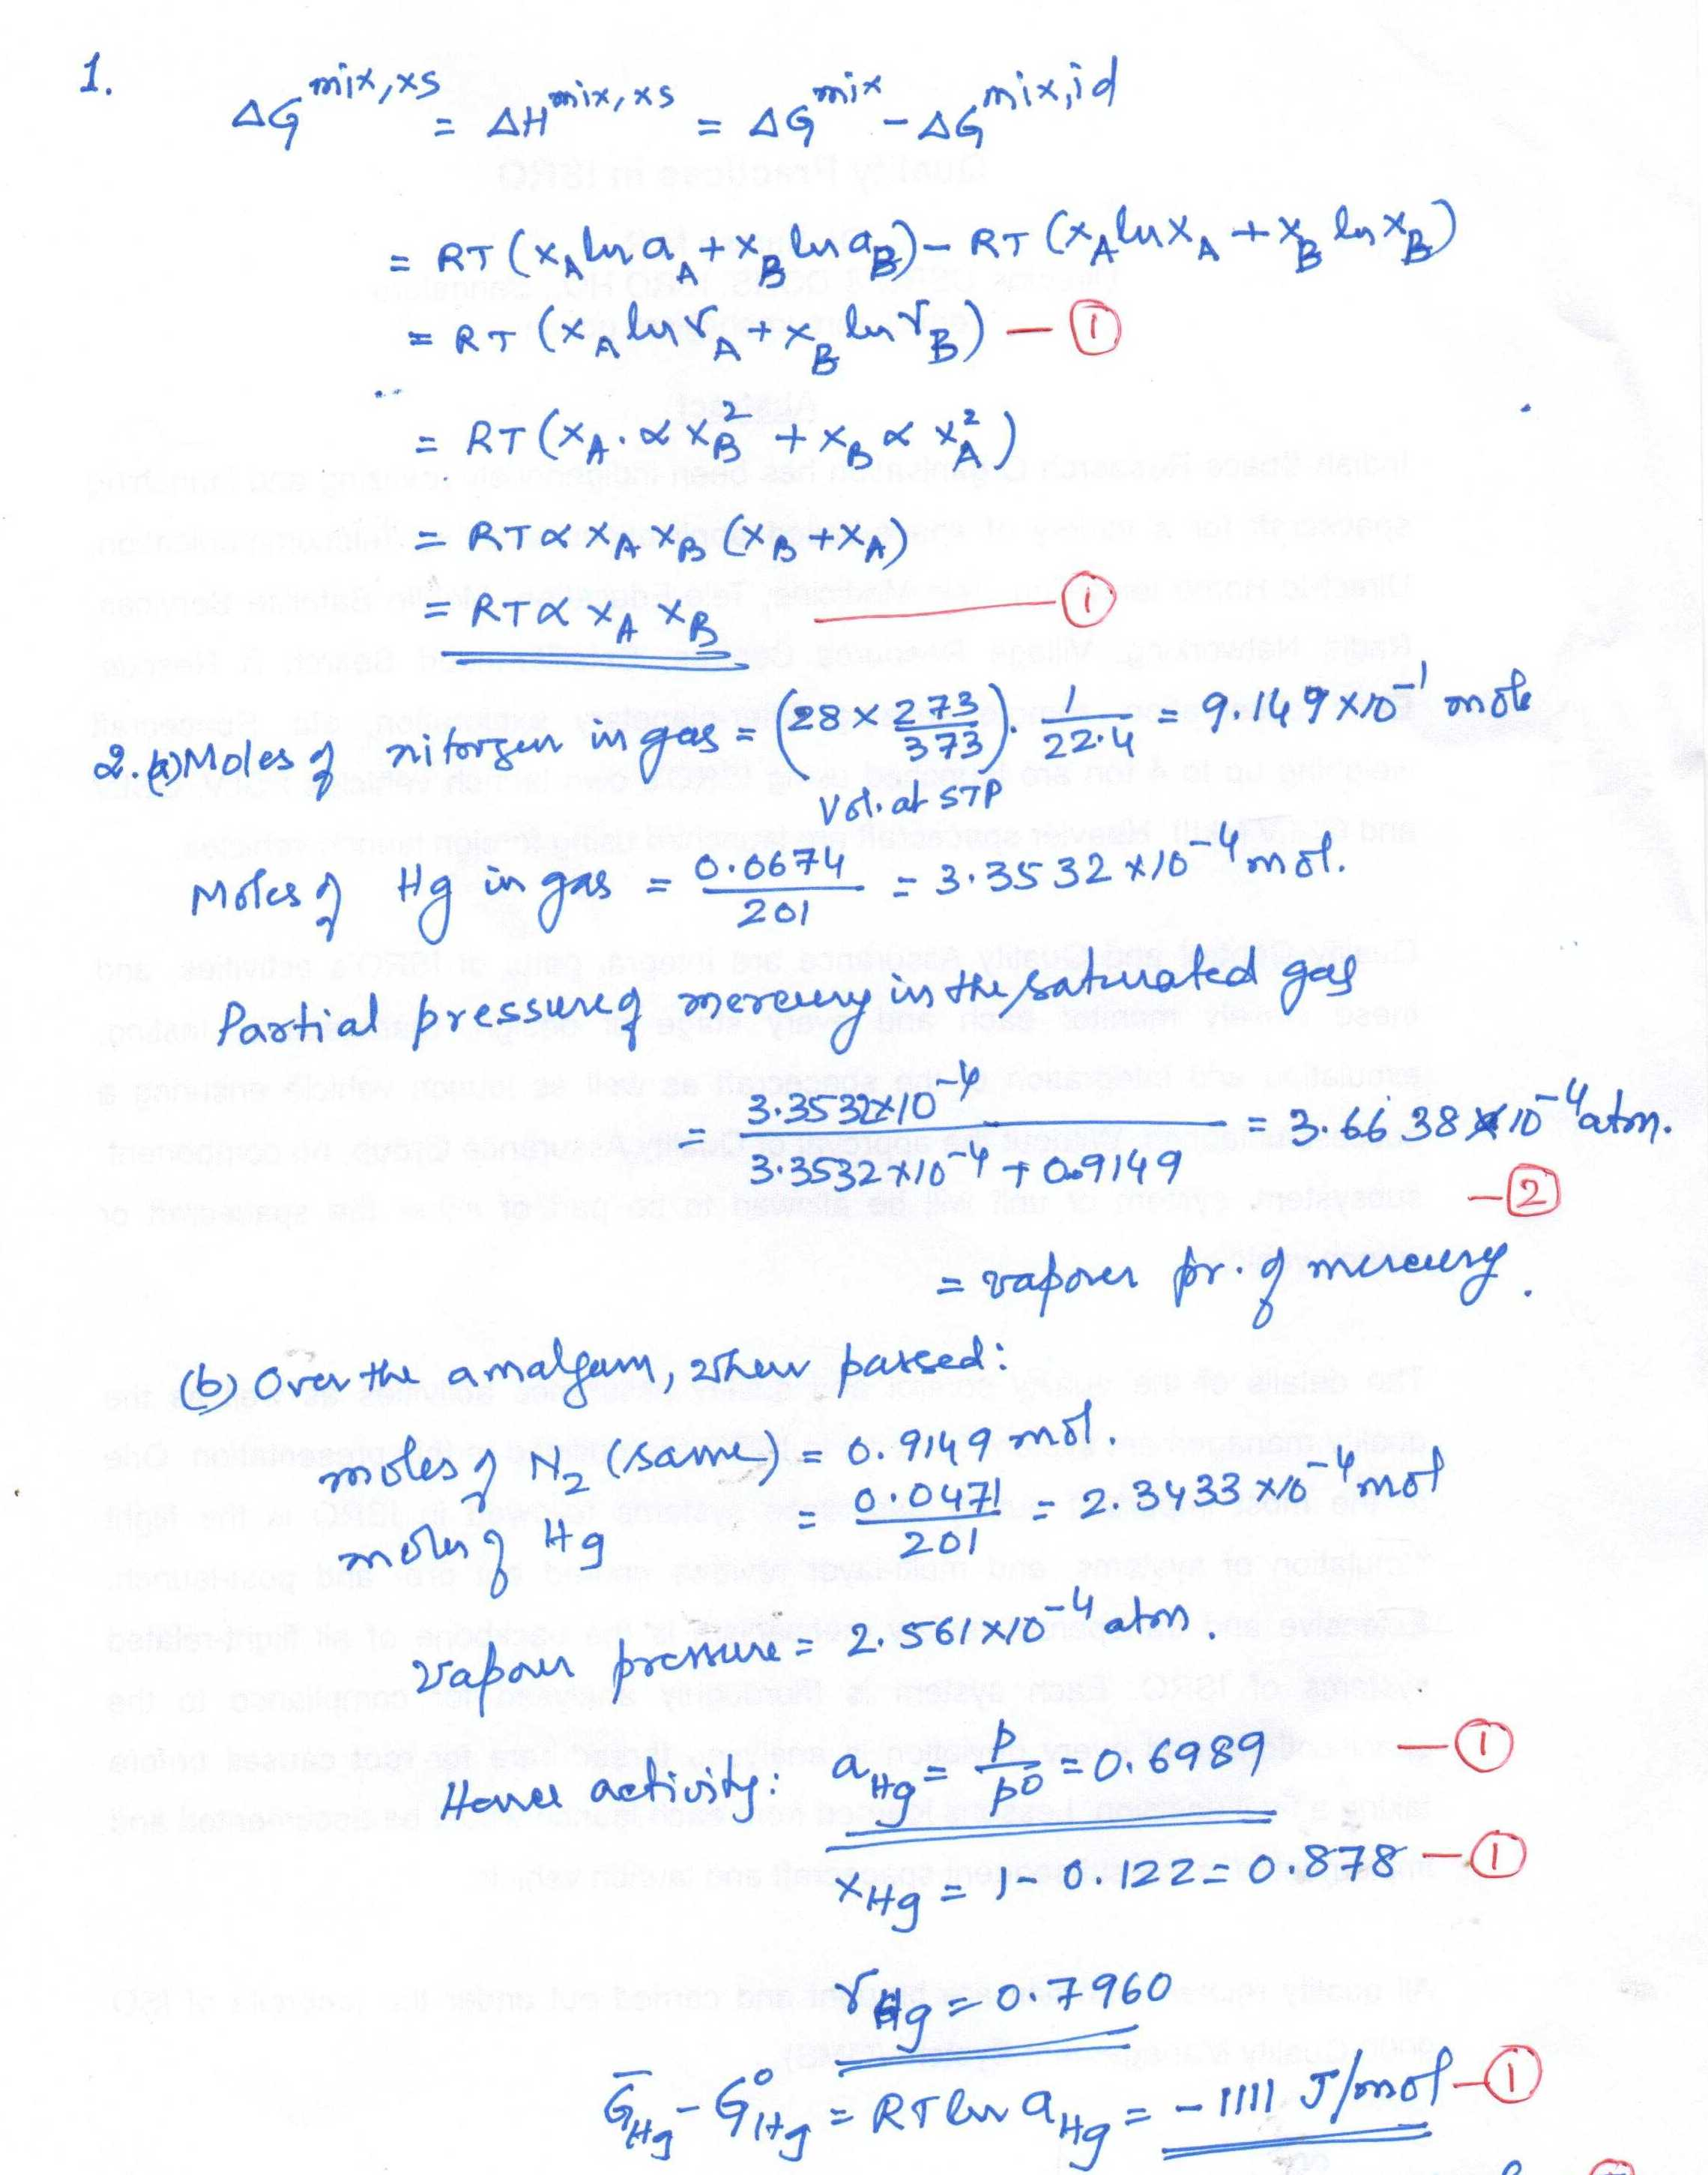

1. CaF2 and MgF2 are mutually insoluble in the solid state (negligible solubility) and form a binary eutectic system. Calculate the composition of the eutectic melt assuming that the liquid solution is Raoultian. Molar heats of melting of CaF2 is 31200 J/mol at the melting temperature of 1691 K and that of MgF2 is 58100 at Tm of 1563K. Assume Cp values of solid and liquid in each pure compound are equal. **You need to only set the equations.** Solving them needs nonlinear solver. The actual eutectic occurs at XCaF2 =0.45 and T = 1243K.

[Hint: a. If you take Goi values for pure solids as 0, at eutectic point the common tangent will be horizontal.

b. Alternatively you can take the equations for Xil/Xis = Exp(…)and put Xis =1]

SOLUTION:



